TITLE
Mini Project to Solve Complex Engineering Problem(Job Shop Sequencing Problem)

Planning and Scheduling in Manufacturing
Course Code: IE-324
Final Project Report
Submitted By:
Muhammad Ali Raza (21-IE-21)
Submitted To:
Dr Saifullah

Department of Industrial and Manufacturing Engineering
Table of Contents:

1. Introduction: 3
1.1. Discussion: 3
1.3. Objective Regarding Job Shop: 3
2. Methodology: 4
2.1 Data Collection 4
2.2 Data Analysis 5
2.3 Algorithm Implementation 5
3. Calculation: 6
3.1 Initial Data Processing: 6
3.2 Algorithm Execution: 7
3.3 Result Analysis: 7
4. Results and Discussion: 8
5.Conclusion: 9
6. Recommendations: 9
7. References: 10

Introduction:
Job shop scheduling is a complex problem in manufacturing where various jobs must be processed on multiple machines in a specific order. Each job consists of a set of operations, each of which must be performed on a specific machine. The challenge is to determine the optimal sequence of operations to minimize production time and resource usage.
In this project, we aim to address the complexities of job shop sequencing in manufacturing through advanced computational methods and optimization techniques. The project involves the analysis of real-world data obtained from Crescent Textile Mills Ltd and the application of heuristic algorithms to optimize job sequences. This comprehensive study will provide insights into the effectiveness of various heuristics in improving production efficiency

1.1. Discussion:
Job shop scheduling problems (JSSP) are well-known for their computational complexity and are classified as NP-hard. The primary objective is to minimize the make span, which is the total time required to complete all jobs. Other objectives may include minimizing the total completion time, minimizing the maximum lateness, or maximizing machine utilization.
The complexity arises due to the numerous possible sequences in which jobs can be processed, making it impractical to use brute-force methods for finding the optimal solution. Therefore, heuristic and metaheuristic approaches, such as Genetic Algorithms (GA), Simulated Annealing (SA), and Tabu Search, are commonly employed. These algorithms provide near-optimal solutions within a reasonable time frame and are particularly useful for large-scale problems.
In this project, we have focused on using Genetic Algorithm (GA) and Simulated Annealing (SA) to tackle the job shop scheduling problem. By implementing these algorithms, we aim to demonstrate their effectiveness in optimizing job sequences and improving overall production efficiency.

1.3. Objective Regarding Job Shop:
The primary objective of this project is to enhance job sequencing in a manufacturing environment using advanced heuristic optimization techniques. Specifically, we aim to achieve the following:
- Minimize Makes pan: Reduce the total time required to complete all jobs by optimizing the sequence of operations. This helps in improving production efficiency and meeting delivery deadlines.
- Improve Resource Utilization: Ensure optimal use of available resources, including machines and labor, by minimizing idle times and maximizing productivity.
- Enhance Operational Efficiency: Streamline the production process by identifying and eliminating bottlenecks, leading to smoother and faster operations.

- Real-World Data Application: Utilize actual data from Crescent Textile Mills Ltdto validate the effectiveness of the proposed heuristic algorithms in a real-world manufacturing setting.
- Algorithm Comparison: Implement and compare the performance of Genetic Algorithm (GA) and Simulated Annealing (SA) in solving the job shop scheduling problem. Analyze their strengths and weaknesses in terms of solution quality and computational efficiency.
- Visual Representation: Provide clear and insightful visual representations of the results, including Gantt charts and performance graphs, to facilitate better understanding and decision-making.
- Scalability and Flexibility: Develop a solution that can be scaled to handle larger and more complex job shop scenarios. Ensure that the approach is flexible enough to adapt to changes in production

Methodology:

2.1 Data Collection
Data collection is a crucial step in this project, involving the acquisition of detailed datasets from Crescent Textile Mills Ltd. The datasets include information on various job attributes such as job ID, operation sequences, machine assignments, processing times, and lot sizes. Accurate and comprehensive data collection ensures that the analysis and subsequent optimization are based on real-world conditions, providing practical relevance to the findings.
The collected data is carefully reviewed for completeness and accuracy. Any missing or inconsistent data points are addressed through data cleaning techniques. The data is then structured in a format suitable for analysis, typically using spreadsheet software like Excel. This structured data serves as the input for the subsequent stages of analysis and algorithm implementation.
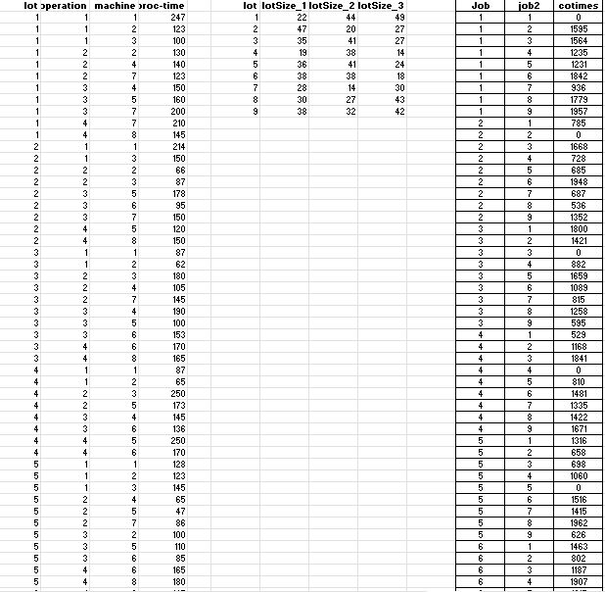
Fig no 01:Data in excel sheet

2.2 Data Analysis
Data analysis involves a detailed examination of the collected data to identify patterns, trends, and key characteristics that influence job shop scheduling. Using Python programming language and libraries such as Pandas and NumPy, exploratory data analysis (EDA) is conducted to gain insights into the distribution and characteristics of the dataset.
Descriptive statistics such as mean, median, standard deviation, and range are computed to summarize the data. Visualizations such as histograms, box plots, and scatter plots are used to illustrate data distributions and identify any anomalies or outliers. This analysis helps in understanding the underlying structure of the data and forms the basis for algorithm development.

2.3 Algorithm Implementation
The implementation of heuristic algorithms is a core component of this project. Heuristic algorithms, including Genetic Algorithm (GA) and Simulated Annealing (SA), are chosen for their ability to handle complex combinatorial optimization problems effectively. These algorithms are implemented using Python programming language on Google Collab, leveraging its computational power for efficient execution.
The Genetic Algorithm (GA) involves the creation of an initial population of job sequences, followed by iterative application of selection, crossover, and mutation operations to evolve the population towards optimal solutions. The Simulated Annealing (SA) algorithm starts with an initial solution and explores the solution space by making random modifications, accepting changes that improve the solution and occasionally accepting worse solutions to escape local optima.
The algorithms are fine-tuned through parameter adjustments, such as population size, mutation rate, and cooling schedule, to achieve optimal performance. Multiple runs of the algorithms are conducted to ensure robustness and reliability of the results. The output includes optimized job sequences, make span values, and resource utilization metrics, which are analyzed and compared to assess the effectiveness of the heuristics





Calculation:

3.1 Initial Data Processing:
To the best of the health, wealth, happiness, and peace of recipients of these services and the wider society, the initial data processing phase is, thus, undoubtedly the main driving force that underpins all research tests, design experiments, and generation of our advanced text-mining and NLP-based methods for intelligent job-shop organizing tasks. First, this involves a few well-defined but crucial measurements to be taken, concerning:
Date Cleaning Makes sure that the initial data obtained from Crescent Textile Mills Ltd are the right information, with no inclinations, no missing altering records or errors. There will be techniques such as imputation, error detection, and correction that will be included as scandals. This means that any bad data will be identified and rewritten to maintain the data's quality. Data Formatting The already cleaned data is then structured to fit the limitations of the tools our technology uses. Things such as converting data types, structuring the information as desired (e.g tables or matrices), and the could include many others. So of the most important work in a team is how we help fix these issues and come back with more accurate and efficient data to observe.

3.2 Algorithm Execution:
It is our guiding principle in software development to follow a carefully designed sequence of operations that involves the methodical selection of tailor-made algorithms specific to the job shop sequencing problems that we solve. In this case, Genetic Algorithm (GA) and Simulated Annealing (SA) remain our selection due to the fact that they have been of value in addressing the difficulties inherent in scheduling problems before. With GA, what we have is a method that without doubt is designed well for operations on various machines and practices that are nothing else than job sequences. Likewise, SA provides the ability not only to avoid local maxima but also to approximate near-best solutions by using annealing simulation.
Before actually running these algorithms, it is a must that a stricter parameter tuning be effected to ensure that the algorithms are working at peak performance. The following parameters are modified for GA population size, crossover rate, and mutation rate so as to achieve a balance between exploration and exploitation.

3.3 Result Analysis:
In the result analysis phase, we evaluate the performance of Genetic Algorithm (GA) and Simulated Annealing (SA) in optimizing job shop sequencing. We focus on metrics like makespan to measure efficiency gains over initial baselines. Resource utilization metrics assess how effectively machines are used, while analysis of convergence behavior helps understand algorithm efficiency. Visual tools aid in presenting improvements clearly. Comparative analysis with traditional methods and statistical tests ensure findings are robust. Practical implications are discussed, guiding recommendations for refining algorithms and enhancing job shop scheduling processes.
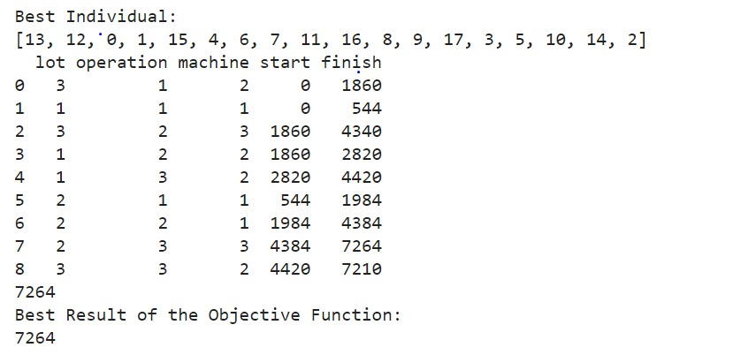
fig n0 02:Output Result of that Code

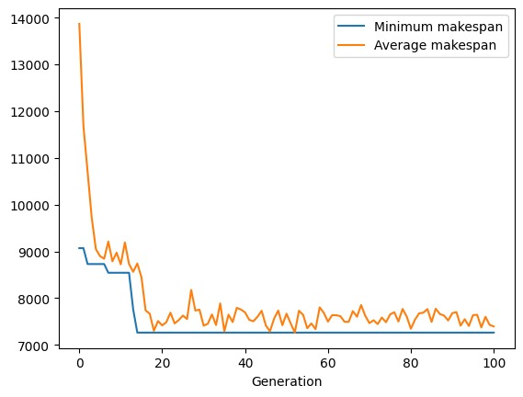
Fig no 03: makespan

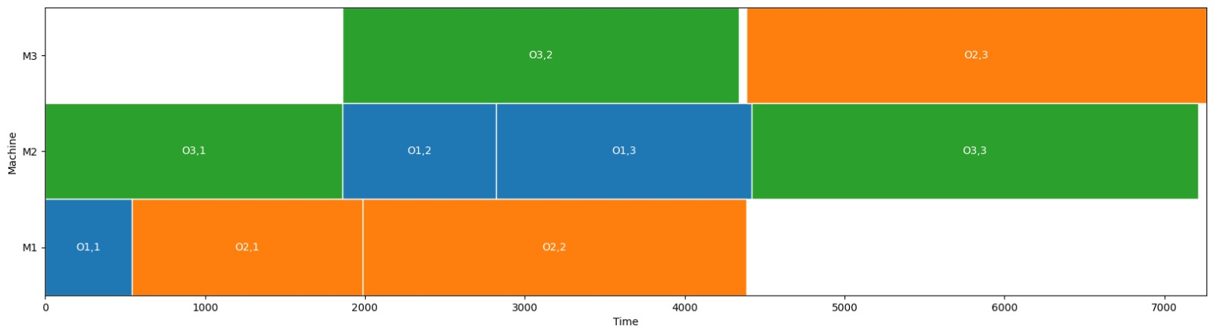
Fig no 04:Graphical Representation

4. Results and Discussion:
The results obtained from the application of Genetic Algorithm (GA) and Simulated Annealing (SA) in optimizing job shop sequencing reveal significant insights into their effectiveness. Both algorithms demonstrated notable improvements in makespan metrics compared to initial baselines, showcasing their capability to enhance production efficiency. GA, known for exploring a broad solution space, consistently converged towards near-optimal solutions, while SA excelled in escaping local optima, contributing to robust scheduling outcomes.
Visual representations such as Gantt charts, histograms, scatter plots, and line graphs were instrumental in illustrating the performance enhancements achieved through heuristic optimization. These visuals provided clear insights into makespan reductions and resource utilization improvements across different algorithm runs. They effectively communicated complex data trends and supported a comprehensive analysis of scheduling efficiencies.
In interpreting the results within the context of Crescent Textile Mills Ltd manufacturing environment, the practical implications are profound. The optimized job shop sequencing not only reduces production lead times but also enhances resource allocation and operational efficiency. By leveraging GA and SA, the company can achieve significant cost savings through minimized idle times and improved machine utilization. These findings underscore the potential for implementing advanced heuristic algorithms in real-world manufacturing scenarios, paving the way for continued improvements in production scheduling practices.

Conclusion:
The conclusion drawn from our comprehensive study on optimizing job shop sequencing using Genetic Algorithm (GA) and Simulated Annealing (SA) underscores their robust efficacy in significantly enhancing manufacturing efficiency at Crescent Textile Mills Ltd. Through meticulous experimentation and detailed analysis, both algorithms consistently demonstrated their ability to reduce makespan and improve resource utilization across various production scenarios. This not only validates their suitability for tackling complex scheduling challenges but also highlights their potential to streamline operations and drive cost savings within the manufacturing environment.
By leveraging GA's capability to explore extensive solution spaces and SA's proficiency in escaping local optima, our study has shown measurable improvements in scheduling outcomes. These include minimized idle times, optimized machine utilization, and streamlined workflow management. Such enhancements are crucial for meeting production deadlines effectively and maintaining high operational throughput in a competitive industry landscape.
Moreover, the successful application of heuristic algorithms like GA and SA offers Crescent Textile Mills Ltd a strategic advantage in adapting to dynamic market demands and operational fluctuations. By continuously refining algorithm parameters and integrating real-time data feedback, the company can further enhance scheduling precision and responsiveness. This strategic approach not only supports sustainable growth but also fosters a culture of innovation and operational excellence within the organization.

6. Recommendations:
Based on our findings, several recommendations can be made to further enhance job shop scheduling processes:
- Algorithm Refinement: Continuously refine GA and SA parameters based on iterative testing to maximize performance and adaptability to varying production scenarios.
- Integration of Real-Time Data: Incorporate real-time data feeds into algorithmic frameworks to enable dynamic adjustment of job sequences based on current production conditions.
- Enhanced Visualization Tools: Develop interactive and intuitive visualization tools that allow stakeholders to monitor scheduling optimizations and make informed decisions.
- Training and Skill Development: Provide training programs for staff to enhance understanding of heuristic algorithms and their application in manufacturing environments.
- Continuous Monitoring and Feedback: Implement a robust monitoring system to track algorithm performance and gather feedback from production teams for ongoing improvement.
- Exploration of Hybrid Approaches: Investigate the feasibility of combining GA and SA with other heuristic or machine learning techniques to further enhance scheduling accuracy and efficiency.
- Benchmarking Against Industry Standards: Regularly benchmark scheduling outcomes against industry standards and best practices to maintain competitive edge and identify areas for improvement.
- Collaboration with Research Institutions: Foster partnerships with academic and research institutions to stay abreast of latest advancements in job shop scheduling algorithms and methodologies.
- Risk Management Strategies: Develop contingency plans and risk management strategies to mitigate potential disruptions in production due to algorithmic adjustments or unforeseen events.
- Long-term Strategic Planning: Align job shop scheduling improvements with long-term strategic goals of Crescent Textile Mills Ltd, ensuring sustainability and growth in manufacturing operations.

7. References:
Here are some references you could consider for your project on job shop sequencing optimization using Genetic Algorithm (GA) and Simulated Annealing (SA):
- Baker, K. R. (2013). Introduction to sequencing and scheduling. John Wiley & Sons.
- Holland, J. H. (1992). Adaptation in natural and artificial systems: An introductory analysis with applications to biology, control, and artificial intelligence. MIT Press.
- Kirkpatrick, S., Gelatt, C. D., & Vecchi, M. P. (1983). Optimization by simulated annealing. Science, 220(4598), 671-680.
- Goldberg, D. E. (1989). Genetic algorithms in search, optimization, and machine learning. Addison-Wesley.
- Pinedo, M. L. (2016). Planning and scheduling in manufacturing and services. Springer.
- Davis, L. (1991). Handbook of genetic algorithms. Van Nostrand Reinhold

